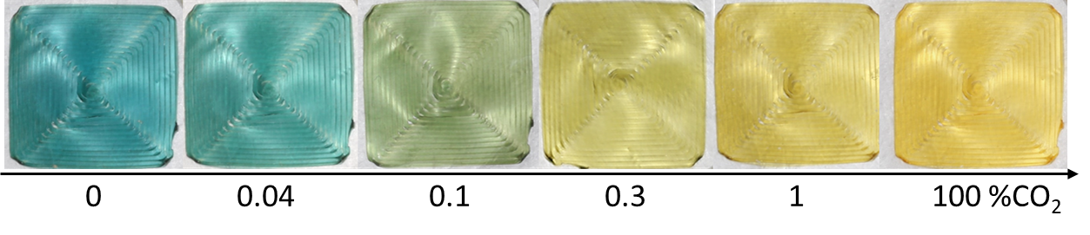



#dbbaac

#debfb1





#d6b1a0

#d9b6a6





#d1a895

#d4ac9a